**CHM 112_2021**

**Periodic Properties of the Atoms of an Element**

Top of Form

Bottom of Form

**Electron/Electronic Configuration**

This is the arrangement of electrons in an atom. In a hydrogen atom and many electron system, the electrons are arranged following certain rules

**General Rules for Assigning Electrons to Atomic Orbitals**

The electrons of an atom exist in discrete atomic orbitals and the way these electrons are arranged (electronic configuration of atom) can be determined using a set of guidelines.

**Note that:**

* If the energy of an atom is increased, an electron in the atom gets excited and releases this energy to go back to its ground state. The energy of the light in this transition is the energy difference between the two levels.
* Electrons are arranged in shells around the nucleus of an atom. Electrons closest to the nucleus have the lowest energy while those further away higher energy. In a given shell, the maximum number of electrons obtainable is 2n2 (n is the principal quantum number).
* Electrons move in atomic orbitals and there are four different orbital shapes: s, p, d, and f. In a given shell, the s subshell is at a lower energy than the p.
* There are guidelines for determining the electronic configuration of an atom. An electron moves to the orbital with lowest energy and an orbital can hold only one electron pair.

**Energy of Electrons in Atomic Orbitals**

The centre of an atom is the nucleus, which contains protons and neutrons. This nucleus is surrounded by electrons each of which has a different amount of energy. Electrons with the lowest energy are found closest to the nucleus where the attractive force of the positively charged nucleus is the greatest. Electrons that have higher energy are found further away.

**Quantization of Energy**

When the energy of an atom is increased (for instance, when it is heated), the energy of its electrons is also increased (the electrons get excited). For the excited electron to go back to its original energy, or ground state, it needs to release energy. One way an electron can release energy is by emitting light. Each element emits light at a specific frequency (or colour) corresponding to the energy of the electronic excitation.

The level of an electron and the amount of energy it can have are not continuous. The separation of electrons into energy units is called quantization of energy because there are only certain quantities of energy that an electron can have in an atom. The energy of the light released when an electron drops from a higher energy is called its energy of transition.

**Electron Shells**

In a simple way,electrons are arranged in energy levels or shells around the nucleus of an atom. Electrons in the first energy level (energy level 1) are closest to the nucleus and have the lowest energy while those further away have higher energy values. Since the electronic shell of an atom can accommodate 2n2 electrons, the first shell can accommodate 2 x (1)2 or 2 electrons and the second shell accommodates 2 x (2)2, or 8, electrons.

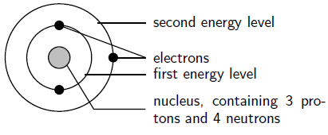

**The arrangement of electrons in a lithium atom**: Lithium (Li) has an atomic number of 3, meaning that in a neutral atom, there are 3 electrons. The energy levels are shown as concentric circles around the nucleus and the electrons are placed from the inside out. The first two electrons are found in the first energy level while the third is in the second energy level.

Fluorine (F), whose atomic number is 9, has 9 electrons in its neutral atom. The first 2 electrons are found in the first energy level and the other 7 are found in the second energy level.

**Atomic Orbitals**

Though electrons can be represented simply as circulating objects around the nucleus in rings, in reality, electrons move along paths that are much more complicated. These paths are called atomic orbitals (subshells). There are several different orbital shapes (s, p, d and f). The first energy level contains only an s orbital, the second energy level contains one s orbital and three p orbitals while the third contains one s orbital, three p orbitals and five d orbitals. Within each energy level, the s orbital is at a lower energy than the p orbitals.

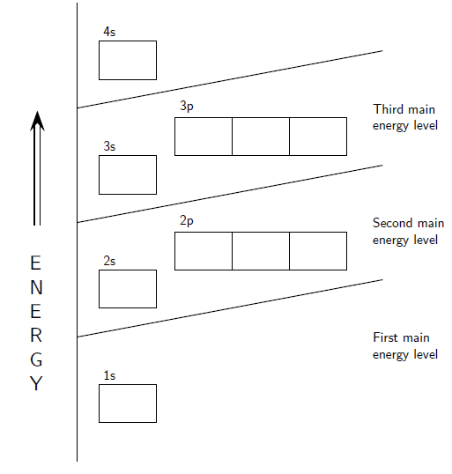

**Orbital diagram**: The positions of the first ten orbits of an atom on an energy diagram. Note that each block is able to hold two electrons.

An orbital diagram helps to establish the electron configuration of an element and the electronic configuration of an element is the arrangement of the electrons in the shells of its atom. There are a few guidelines for working out this configuration:

* Each orbital can hold only two electrons and if they occur together in an orbital they are paired.
* An electron will always try to enter the orbital with the lowest energy.
* An electron can occupy an orbital on its own occupying a lower-energy orbital with another electron before that of higher energy. Thus, within an energy level, electrons fill in an s orbital before p.
* The s subshell can hold 2 electrons while the p subshells can hold 6 electrons.

Electronic configurations can be used to rationalize chemical properties in both inorganic and organic chemistry. It is also used to interpret atomic spectra (the method used to measure the energy of light emitted from elements and compounds).

**The Building-Up (Aufbau) Principle**

The Aufbau principle presents the electronic configuration of an atom by adding electrons to atomic orbitals following a defined set of rules.

Using this rule, the following points are noted

* The Madelung rule which states that electrons fill orbitals starting at the lowest available energy state before filling higher states is obeyed.
* Aufbau procedure which stipulates the filling in of the available orbitals starting with the lowest-energy levels first and avoiding pairing of electrons in a single orbital until it is necessary is adopted.
* Electronic configuration gives the energy levels, orbitals and number of electrons in an atom while the numbers and letters describe the energy levels and orbitals respectively with the superscript numbers showing how many electrons are in that orbital.
* The Aufbau principle works well for the first 18 elements but becomes less useful afterwards.
* Pauli Exclusion Principle**,** which states that no two identical electrons or fermions (particles with half-integer spin) may occupy the same quantum state simultaneously, is strictly followed while filling in electrons in atomic orbitals.

**Atoms Are Built Up by Adding Electrons**

Although the nucleus of an atom is very dense, the electrons around it can take on a variety of positions referred as its electronic configuration which can be represented using energy level diagrams, or Aufbau diagrams. The Aufbau principle (from the German *Aufbau* meaning “building up, construction”) describes progressive addition of electrons in an atom. As electrons are added, they assume the most stable shells with respect to the nucleus and the electrons already present.

**Filling in an Aufbau Diagram**

The order in which orbitals are filled is given by the Madelung rule. The rule is based on the total number of nodes in the atomic orbital, n and ℓ. In this context, n which is related to the energy, represents the principal quantum number and ℓ represents the azimuthal quantum number. The values ℓ = 0, 1, 2, 3 correspond to the s, p, d and f orbitals respectively. This is done in accordance with the Madelung energy ordering rule which specifiesthe **o**rder in which orbitals are arranged by increasing energy as shown below and each diagonal red arrow corresponds to a different value of n + 1.

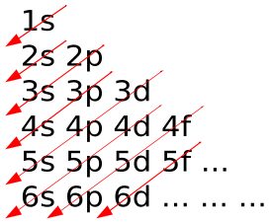

An Aufbau diagram uses arrows to represent electrons and when there are two electrons in an orbital, they are said to be paired while a single electron is said to be unpaired. Electron pairs are shown with arrows pointing in opposite directions. According to the Pauli Exclusion Principle, two electrons in an orbital will not spin the same way. Thus, an Aufbau diagram uses arrows pointing in opposite directions. An arrow pointing up denotes an electron spinning one way and an arrow pointing downwards denotes an electron spinning the other way. Thus for a lithium atom, this can be given as:

image

The following steps give how to draw an Aufbau diagram:

1. Determine the number of electrons that the atom has.
2. Fill the s orbital in the first energy level (the 1s orbital) with the first two electrons.
3. Fill the s orbital in the second energy level (the 2s orbital) with the second two electrons.
4. Put one electron in each of the three p orbitals in the second energy level (the 2p orbitals) and then if there are electrons remaining, place a second one in each of the 2p orbitals to complete the electron pairs.
5. Continue in this way through each of the successive energy levels until all the electrons have been drawn. Thus for fluorine, the Aufbau diagram below can be used to show its electronic configuration.

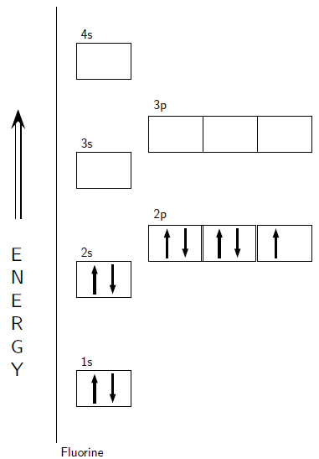

**Standard Notation for Electronic Configurations**

The special type of notation used to write electronic configuration of an atom describes the energy levels, orbitals and number of electrons in each. For example, the electronic configuration of lithium is 1s22s1 with the number and letter describing the energy level and orbital. The number above the orbital shows how many electrons are in that orbital and using standard notation, the electron configuration of fluorine is 1s22s22p5.

**Limitations of Aufbau Principle**

The Aufbau principle is based on the idea that the order of orbital energies is fixed. This assumption is approximately true but not physically reasonable. It models atomic orbitals as “boxes” of fixed energy into which at most two electrons can be placed. However, the energy of an electron in an atomic orbital depends on the energies of all the other electrons of the atom.

In a hydrogen-like atom, the s and p-orbitals of the same shell in the Aufbau diagram have exactly the same energy. However, in a real hydrogen atom, the energy levels are slightly split by the magnetic field of the nucleus. Since each atom has a different number of protons in its nucleus, the magnetic field differs thus altering the pull on each electron. In general, the Aufbau principle works very well for the ground states of the atoms for the first 18 elements but less satisfactorily for the following 100 elements.

**N.B.** The likely location of an electron around the nucleus of an atom is called an orbital and its shape depends on the energy state of the electron.

**Hund’s Rule**

Hund’s Rule defines the behaviour of unpaired valence shell electrons, providing insight into an atom’s reactivity and stability.

**Points to Note**

* Hund’s Rule states that every orbital in a sublevel is singly occupied before any orbital is doubly occupied and all of the electrons in singly occupied orbitals have the same spin.
* Electrons arrange themselves in order to minimize energy of interaction, thus always occupying an empty orbital before pairing to minimize repulsion. Unpaired electrons have the same spins because they meet less often if moving in the same direction than in opposite directions.
* To avoid confusion, the first electron and any other unpaired electron in an orbital is always drawn as “spin-up.”
* Electronic configurations help in the predictions about the reactivity of elements. An atom is most reactive when its valence shell is not full and most stable when its valence orbitals are full and elements with the same number of valence electrons have similar properties.

**Relation to Aufbau Principle**

Electrons fill the lowest energy orbitals first before those of higher energy only after the lower energy orbitals are full. This is referred to as the Aufbau Principle. Although the implications are clear for orbitals of different principal quantum number (n), the filling order is less clear for degenerate sublevels. For example, for boron through neon, the electron filling order of the 2p orbitals follows Hund’s Rule.

Hund’s Rule states that:

1. Every orbital in a sublevel is singly occupied before any orbital is doubly occupied.
2. All of the electrons in singly occupied orbitals have the same spin.

**Hund’s Rule Explained**

According to the first rule, electrons will always occupy an empty orbital before pairing up. Electrons are negatively charged thus, they repel each other. Electrons tend to minimize repulsion by occupying their own orbital rather than sharing. Also, quantum-mechanical calculations have shown that the electrons in singly occupied orbitals are less effectively screened or shielded from the nucleus.

For the second rule, unpaired electrons in singly occupied orbitals have the same spins. If all electrons are orbiting in the same direction, they meet less often than if some of them orbit in opposite directions thus increasing the repulsive force which separates electrons. Therefore, spins that are aligned have lower energy.

The first electron in a sublevel could either be “spin-up” or “spin-down” and once the spin of the first electron in a sublevel is chosen, the spins of all others in that sublevel depend on that of the first. To avoid confusion, the first electron and any other unpaired ones in an orbital are “spin-up.”

**Applying Hund’s Rule**

Considering the electronic configuration of carbon, 2 electrons will pair up in the 1s orbital, 2 electrons pair up in the 2s orbital and the remaining 2 will be placed in the 2p orbitals. The correct orbital diagram, obeying Hund’s Rule, will put the two 2p electrons as unpaired in two of the three available orbitals, both with “spin-up.” Since electrons always occupy an empty orbital before they fill up, it would be incorrect to draw the two 2p electrons in the same orbital, leaving open orbitals unfilled.

As another example, oxygen has 8 electrons. The electron configuration can be written as 1s22s22p4. The orbital diagram is drawn as follows: the first 2 electrons will pair up in the 1s orbital; the next 2 will pair up in the 2s orbital. That leaves 4 electrons, which must be placed in the 2p orbitals. According to Hund’s Rule, all orbitals will be singly occupied before any pairing. Therefore, two p orbitals will each get 1 electron and one will get 2 electrons. Hund’s Rule also tells us that all of the unpaired electrons must have the same spin. Keeping with convention, all the unpaired electrons are drawn as “spin-up.”

**Purpose of Electron Configurations**

When atoms come into contact with one another, their outermost electrons, or valence shell will interact first. An atom is least stable (and therefore most reactive) when its valence shell is not full. The valence electrons are largely responsible for the chemical behaviour of elements. Elements with the same number of valence electrons often have similar chemical properties.

Electron configurations can also predict stability with an atom being at its most stable (and therefore unreactive) state when all its orbitals are full. The most stable configurations are the ones that have full energy levels. These configurations occur in the noble gases. The noble gases are very stable elements that do not react easily with other elements.

Electronic configurations also help in making predictions about reactivity of elements and their chemical compounds or molecules. These principles help to understand the behaviour of all chemicals, from the most basic elements like hydrogen and helium, to the most complex proteins.

**The Shielding Effect and Effective Nuclear Charge**

The shielding effect, approximated by the effective nuclear charge, is due to inner electrons shielding valence electrons from the nucleus.

**Note that:**

* The shielding effect describes the balance between the pull of the protons on valence electrons and the repulsion forces from inner electrons.
* The shielding effect explains why valence-shell electrons are more easily removed from the atom as well as the atomic size. The more shielding, the further the valence shell and the bigger the atom.
* The effective nuclear charge is the net positive charge experienced by valence electrons which is estimated as: Zeff = Z – S, where Z is the atomic number and S is the number of shielding electrons.

**The Shielding Effect**

Electrons in an atom shield each one another from the pull of the nucleus. This effect, called the shielding effect, describes the decrease in attraction between an electron and the nucleus of an atom with more than one electron shells. The more electron shells there are, the greater the shielding effect experienced by the outermost electrons.

In hydrogen-like atoms (have just one electron), the net force on the electron is as large as the electric attraction from the nucleus. However, when more electrons are involved, each electron (in the n-shell) feels not only the electromagnetic attraction from the positive nucleus but also repulsion from other electrons in shells from 1 to n - 1. This causes the net electrostatic force on electrons in outer shells to decrease with distance. Therefore, these electrons are not as strongly bound as electrons closer to the nucleus.

The shielding effect tells why valence shell electrons are more easily removed from the atom. The nucleus can pull the valence shell in tighter when the attraction is strong and less tight when the attraction is weakened. The more the shielding, the further the valence shell and larger the atoms.

**Example**

Why is caesium bigger than sodium?

The electronic configuration of sodium is 1s22s22p63s1 with its outer energy level, n = 3 and one valence electron. The attraction between this lone valence electron and the nucleus with 11 protons is shielded by the other 10 core electrons.

The electronic configuration of caesium is 1s22s22p63s23p64s23d104p65s24d105p66s1. While there are more protons in a caesium atom, there are many more electrons shielding the outer electron from the nucleus. The outermost electron, 6s1, is held very loosely thus the nucleus has less control over this 6s1 electron than it does over a 3s1 electron.

**Effective Nuclear Charge**

The magnitude of the shielding effect is difficult to calculate precisely. As an approximation, the effective nuclear charge on each electron is estimated. The diagram of the concept of effective nuclear charge based on electron shielding is as shown below.

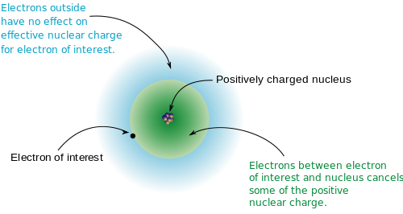

The effective nuclear charge (often symbolized as Zeff or Z*) is the net positive charge experienced by an electron in a multi-electron atom. The term “effective” is used because the shielding effect of negatively charged electrons prevents higher orbital electrons from experiencing the full nuclear charge.

The effective nuclear charge on an electron is given by the following equation:

Zeff = Z – S (1)

where Z is the number of protons in the nucleus (atomic number) and S is the number of electrons between the nucleus and the electron in question (the number of non-valence electrons).

**Example**

Considering a neutral neon atom (Ne), a sodium cation (Na+), and a fluoride ion (F–), what is the effective nuclear charge for each?

First determine the number of non-valence electrons from the electronic configurations.

Ne has 10 electrons with its electronic configuration as 1s22s2 2p6. The valence shell is shell 2 with 8 valence electrons. Thus the number of non-valence electrons is 2 (10 total electrons – 8 valence). The atomic number for neon is 10, therefore:

Zeff(Ne) = 10 – 2 = 8+

Flourine has 9 electrons but F– has gained an electron and thus has 10. The electronic configuration is the same as that of neon and the number of non-valence electrons is 2. The atomic number for F– is 9, therefore:

Zeff(F–) = 9 – 2 = 7+

Sodium has 11 electrons but the Na+ ion has lost an electron and thus has 10. The electronic configuration is 1s22s2 2p6 and the number of non-valence electrons is 2 (by losing one electron, the valence shell becomes the n = 2 shell). The atomic number for Na+ is 11, therefore:

Zeff(Na+) = 11 – 2 = 9+

In each of the above examples (Ne, F–, Na+) the species has 10 electrons but the effective nuclear charge varies because each has a different atomic number. The sodium cation has the largest effective nuclear charge, which results in electrons being held the tightest and therefore Na+ has the smallest atomic radius.

**Diamagnetism and Paramagnetism**

Diamagnetic atoms have only paired electrons, whereas paramagnetic atoms, which can be made magnetic, have at least one unpaired electron.

**Points to Note**

* Whenever two electrons share the same orbital, their spin quantum numbers are different and they paired with their total spin being zero. They are diamagnetic electrons and atoms with all diamagnetic electrons are called diamagnetic atoms.
* A paramagnetic electron is an unpaired electron and an atom is paramagnetic if even one orbital has a net spin. Thus, an atom could have ten diamagnetic electrons and as long as it also has one paramagnetic electron, it is paramagnetic.
* Diamagnetic atoms repel magnetic fields while the unpaired electrons of paramagnetic atoms realign with external magnetic fields and are attracted. Paramagnets do not retain magnetization in the absence of a magnetic field, because thermal energy randomizes electron spin orientations. It is this principle that is employed in **MRI** (Magnetic Resonance Imaging), a medical imaging technique used in radiology to investigate the anatomy and physiology of the body in both health and disease.

**Diamagnetism**

If two electrons share the same orbital, their spin quantum numbers have to be different. That is, one of the electrons has to be “spin-up,” with ms = +½ while the other is “spin-down,” with ms = −½. This is important in determining the total spin in an orbital. In order to decide whether electron spins cancel, add their spin quantum numbers together. Whenever two electrons are paired together in an orbital, or their total spin is 0, they are diamagnetic.

If one spin of an electron is clockwise and the other anticlockwise, then the two spin directions balance each other and there is no leftover rotation. In terms of electrons sharing in an orbital, electrons in the same orbital always have opposite values for their spin quantum numbers (ms), thus always end up canceling each other out thus there is no leftover spin in an orbital that contains two electrons.

Electron spin is very important in determining the magnetic properties of an atom. If all the electrons in an atom are paired and share their orbital with another electron, then the total spin in each orbital is zero and the atom is diamagnetic. Diamagnetic atoms are not attracted to a magnetic field but are rather slightly repelled.

**Paramagnetism**

Unpaired electrons in an orbital are called paramagnetic electrons. If an electron is alone in an orbital, the orbital has a net spin because the spin of the lone electron does not get canceled out. Thus, even if one orbital has a net spin, the entire atom will have a net spin. Therefore, an atom is paramagnetic when it contains at least one paramagnetic electron. That is, an atom could have 10 paired (diamagnetic) electrons, but as long as it also has one unpaired (paramagnetic) electron, it is still paramagnetic.

Just as diamagnetic atoms are slightly repelled from a magnetic field, paramagnetic atoms are slightly attracted to a magnetic field. Paramagnetic properties are due to the realignment of the electron paths caused by the external magnetic field. Paramagnets do not retain any magnetization in the absence of an externally applied magnetic field, because thermal motion randomizes the spin orientations. Stronger magnetic effects are typically observed only when d- or f-electrons are involved. The size of the magnetic moment on a lanthanide atom can be quite large, as it can carry up to seven unpaired electrons, in the case of gadolinium(III) (hence its use in MRI).

**Bohr’s Theory**

In this section, such terms as spectrum and emission are to be dealt with. While a spectrum is a range of colours representing light (electromagnetic radiation) of contiguous frequencies (electromagnetic spectrum, visible spectrum and ultraviolet spectrum), emission, on the other hand, is what occurs when an electronic transition between a higher energy level and a lower one occurs resulting in the release of a photon of predictable energy.

**Emission Spectrum of the Hydrogen Atom**

The emission spectrum of atomic hydrogen is divided into a number of spectral series obtained from the use of Rydberg equation or formula.

Thus it is pertinent to note that:

* The wavelengths in a spectral series are given by the Rydberg formula.
* Observed spectral lines are due to electronic transitions between energy levels in an atom.
* Further series follow exactly the same pattern as dictated by the Rydberg equation.

The emission spectrum of a chemical element or compound is the spectrum of frequencies of electromagnetic radiations emitted by the electrons of its atom(s) when they are returned to lower energy states. The emission spectrum of each element is unique and therefore spectroscopy can be used to identify elements present in matter of unknown composition. Similarly, the emission spectra of molecules can be used in chemical analysis of substances.

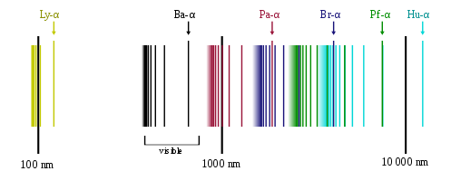

The spectral series of hydrogen, on a logarithmic scale

The emission spectrum of atomic hydrogen is divided into a number of spectral series with wavelengths given by the Rydberg formula:

λvac = RZ2(l/n12 – l/n22) (2)

where R is the Rydberg constant (approximately 1.09737 x 107 m-1), λvac is the wavelength of the light emitted in vacuum, Z is the atomic number, n1 and n2 are integers representing the energy levels involved with n1 < n2. All observed spectral lines are due to electronic transitions between energy levels in the atom. The spectral series are important in astronomy for detecting the presence of hydrogen and calculating red shifts. Further series for hydrogen as well as other elements were discovered as spectroscopy techniques developed.

**The line spectrum of hydrogen**: This explains how the lines in the emission spectrum of hydrogen are related to electron energy levels. The spectral lines are grouped into series according to ‘n′ and are named sequentially starting from the longest wavelength (lowest frequency) using Greek letters within each series. For example, the 2 → 1 line is called Lyman-alpha (Ly-α), while the 7 → 3 line is called Paschen-delta (Pa-δ). Some hydrogen spectral lines such as the 2l cm line (correspond to much rarer atomic events such as hyperfine transitions) fall outside these series. The fine structure also results in single spectral lines appearing as two or more closely grouped thinner lines due to relativistic corrections. These lines are observable only from pure hydrogen samples in a lab and many of them are very faint. Additional lines can be caused by other elements (such as He if using sunlight or N in the air). Lines outside the visible spectrum cannot be seen in observations of sunlight, as the atmosphere absorbs most infrared and ultraviolet wavelengths through the action of water vapour and ozone molecules respectively.

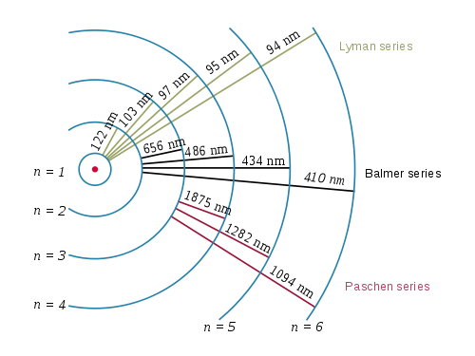

**Three Electron transitions and their resulting wavelengths for hydrogen**

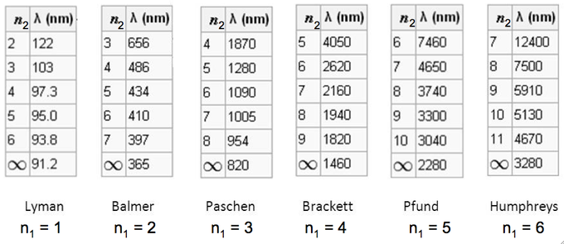

**The emission spectrum of hydrogen**: Some of the most common and readily observable series have been named as shown in this image, where n1 is the ground state and n2 are excited states. The various series named for the atomic energy level end on (n1). The series limit where n2 is infinite and n1 = 1 corresponds to **the ionization energy** of hydrogen.

**The Bohr Model**

The Bohr model depicts atoms as small, positively charged nuclei surrounded by electrons in circular orbits. The use of this model of the atom marked an improvement over earlier models, but still had limitations from its use of **Maxwell’s theory**

**Note the following:**

* The model is able to explain the Rydberg formula for the spectral emission lines of atomic hydrogen.
* The model states that electrons in atoms stably move in fixed circular orbits at discrete sets of distances from the nucleus generally associated with definite energies called **energy shells** or **levels**.
* In these stable orbits, the acceleration of an electron does not result in radiation and energy loss as required by classical electromagnetic theory.

Thus, the Bohr model depicts an atom as a small, positively charged nucleus surrounded by electrons which travel in circular orbits around the nucleus (similar in structure to the solar system, except electrostatic forces rather than gravity provide attraction). Also, the Rutherford-Bohr model of the hydrogen atom says that the electron orbits around the nucleus similar to that of planets around the sun in the solar system.

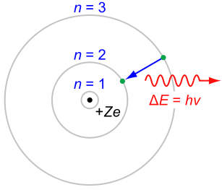

Therefore, from the Rutherford-Bohr model of the hydrogen atom (*Z*= 1) or a hydrogen-like ion (*Z*> 1) depicting the negatively charged electron confined to an atomic shell as revolving round a small, positively charged atomic nucleus, an electron jump between orbits is accompanied by an emitted or absorbed amount of electromagnetic energy (h*v*). The orbits in which the electron may travel are shown as grey circles and their radii increase as *n*2, where *n* is the principal quantum number. The 3 → 2 transition depicted in the diagram produces the first line of the Balmer series, and for hydrogen (*Z* = 1), it results in a photon wavelength of 656 nm (red light).

**Development of the Bohr Model**

The Bohr model was an improvement on the earlier **cubic model** of 1902, the plum-pudding model of 1904, the Saturnian model of 1904 and the Rutherford model of 1911. Since the Bohr model is a quantum physics-based modification of the Rutherford model, many sources combine the two to form: the Rutherford-Bohr model.

Although it challenged the knowledge of classical physics, the success of model lays in explaining the Rydberg formula for the spectral emission lines of atomic hydrogen. While the Rydberg formula had been known experimentally, it did not gain a theoretical importance until the Bohr model was introduced. Not only did the Bohr model explain the reason for the structure of the Rydberg formula, it also provided a justification for its empirical results in terms of fundamental physical constants.

Although revolutionary at its time, the Bohr model is a relatively primitive model of the hydrogen atom compared to the valence shell atom. As an initial hypothesis, it was derived as a first-order approximation to describe the hydrogen atom. Due to its simplicity and correct results for selected systems, the Bohr model is still commonly taught to introduce students to quantum mechanics amd the related model, proposed by Arthur Erich Haas in 1910, was rejected. The quantum theory from the period between Planck’s discovery of the quantum (1900) and the advent of a full-blown quantum mechanics (1925) is often referred to as the old quantum theory.

Early planetary models of the atom suffered from flaws since they had electrons spinning in orbit around a nucleus (charged particle in an electric field). There was no accounting for the fact that the electron would spiral into the nucleus. In terms of emission, this would mean a continuum of frequencies being emitted since, as the electron moved closer to the nucleus, it would move faster and would emit a different frequency from those experimentally observed. These planetary models ultimately predicted all atoms to be unstable due to the orbital decay. The Bohr Theory solved this problem and correctly explained the experimentally obtained Rydberg formula for emission lines.

**Properties of Electrons under the Bohr Model**

In 1913, Bohr suggested that electrons could only have certain classical motions:

1. Electrons in atoms orbit the nucleus.
2. The electrons can only orbit stably, without radiating, in certain “stationary orbits” at certain discrete set of distances from the nucleus. These orbits, also called energy shells or energy levels, are associated with definite energies. In these orbits, the acceleration of an electron does not result in radiation and energy.
3. Electrons can only gain or lose energy by jumping from one allowed orbit to another, absorbing or emitting electromagnetic radiation with a frequency (ν) determined by the energy difference of the levels according to the Planck relation.

**Combining the knowledge of the nature of light with Bohr’s atomic theory**

Bohr’s model is significant because the laws of classical mechanics apply to the motion of the electron about the nucleus only when restricted by a quantum rule. Although Rule 3 is not completely well defined for small orbits, Bohr could determine the energy spacing between levels using Rule 3 and came to an exactly correct quantum rule (the angular momentum *L* is an integer multiple of a fixed unit).

Thus, L = nh/2π = nℏ (3)

where n = 1, 2, 3,… is called the principal quantum number and ħ = h/2π. The lowest value of n is 1 which gives the smallest possible orbital radius of 0.0529 nm, known as the Bohr radius. Once an electron is in this orbit, it can get no closer to the proton. Starting from the angular momentum quantum rule, Bohr calculated the energies of the allowed orbits of the hydrogen atom and other hydrogen-like atoms and ions.

**The Correspondence Principle**

Like Einstein’s theory of the photoelectric effect, Bohr’s formula assumes that during a quantum jump, a discrete amount of energy is radiated. However, unlike Einstein, Bohr stuck to the classical Maxwell theory of the electromagnetic field. Quantization of the electromagnetic field was explained by the discreteness of the atomic energy levels. Bohr however, did not believe in the existence of photons.

According to the Maxwell theory, the frequency (*ν)* of classical radiation is equal to the rotation frequency (*νrot)* of the electron in its orbit with harmonics at integer multiples of this frequency. This result is obtained from the Bohr model for jumps between energy levels *En* and *En−k* when *k* is much smaller than *n*. These jumps reproduce the frequency of the *k-*th harmonic of orbit *n*. **For sufficiently large values of *n***(so-called Rydberg states), **the two orbits involved in the emission process have nearly the same rotation frequency** so that the classical orbital frequency is not ambiguous. However, for small *n* (or large *k*), the radiation frequency has no unambiguous classical interpretation. This marks the birth of the correspondence principle, requiring quantum theory to agree with the classical theory only in the limit of large quantum numbers.

The Bohr-Kramers-Slater theory (BKS theory) is a failed attempt to extend the Bohr model, which violates the conservation of energy and momentum in quantum jumps, with the conservation laws only holding on average.

**The de Broglie Wavelength**

The de Broglie wavelength is inversely proportional to the momentum of a particle. In considering this approach to small particles like atoms and subatomic particles, the following points are to be noted.

* At the end of the 19th century, light was thought to consist of waves of electromagnetic fields that propagated according to Maxwell’s equations while matter was thought to consist of localized particles.
* In his 1905 paper on the photoelectric effect, Albert Einstein postulated that light was emitted and absorbed as localized packets or quanta (photons).
* De Broglie showed that the theory of relativity was applicable to not just photons but also all particles with linear momentum thus matter, including electrons, also has wave-like properties.

At the end of the 19th century, light was thought to consist of waves of electromagnetic fields that propagated according to Maxwell’s equations, while matter was thought to consist of localized particles. This division was challenged when, in his 1905 paper on the photoelectric effect, Albert Einstein postulated that light was emitted and absorbed as localized packets or quanta (photons). These quanta would have an energy of:

E = hv (4)

where *v* is the frequency of the light and *h* is Planck’s constant. Einstein’s postulate was confirmed experimentally by Robert Millikan and Arthur Compton. Thus it became apparent that light has both wave-like and particle-like properties. In his 1924 PhD thesis, de Broglie sought to expand this wave-particle duality to all material particles with linear momenta.

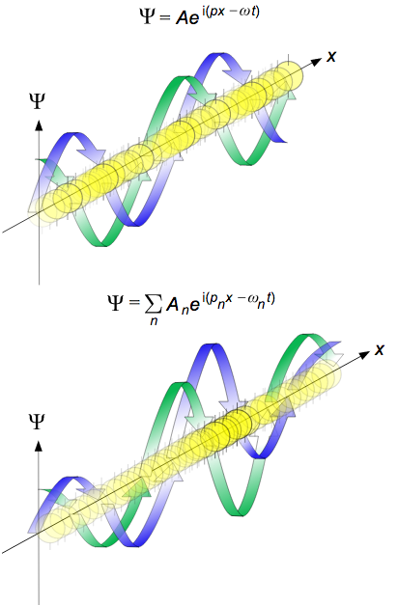

**de Broglie waves**: Propagation of de Broglie waves in 1 dimension (the real part of the complex amplitude is blue and the imaginary part is green; top: plane wave, bottom: wave packet). The probability (shown as the colour opacity) of finding the particle at a given point x is spread out like a wave with no definite position of the particle. As the amplitude increases above zero the curvature decreases, so the amplitude decreases again and vice versa (the result is an alternating amplitude, a wave).

In 1926, Erwin Schrödinger published an equation describing how a matter wave should evolve (the matter wave equivalent of Maxwell’s equations) and used it to derive the energy spectrum of hydrogen. That same year, Max Born published his standard interpretation that states that the square of the amplitude of a matter wave gives the probability of finding a particle at a given place. This interpretation was in contrast with de Broglie’s own interpretation, in which the wave corresponds to the physical motion of a localized particle.

**The De Broglie Equations**

The de Broglie equations relate the wavelength (λ) to the momentum (*p)* and the frequency (*f)* to the kinetic energy (E) (excluding its rest energy and any potential energy).

λ = h/p and f = E/h (5)

where h is Planck’s Constant. The two equations can be written as

p = ℏk and E = ℏω (6)

where ℏ = h/2π (7)

ℏ is the reduced Planck’s constant with

k = 2π/λ; (8)

which is the angular wavenumber and

ω = 2πf (9)

Where ω js the angular frequency.

De Broglie realized that in a one-electron atom, for a wave to have a stable amplitude and not decay over time, an integer number (n) of wavelengths must fit into a single circumference drawn by the Bohr orbit. He related this to the principal quantum number n through the equation:

nλ = 2nπr, λ = 2πr (10)

This was fortunately reminiscent of Bohr’s observation about the angular momentum of an electron, which had already been established:

mevr =2πrnr (11)

mev = 2πnr (12)

By inspection of the above and with minor rearrangement, the de Broglie relation can be obtained as:

λ = hmev = hp (13)

**Confirming the de Broglie Hypothesis**

In 1927 at Bell Labs, Clinton Davisson and Lester H. Germer fired slow-moving electrons at a crystalline nickel target. The angular dependence of the reflected electron intensity was measured and found to have the same diffraction pattern as those predicted by Bragg for X-rays. Before the acceptance of the de Broglie hypothesis, diffraction was a property that was thought to only be exhibited by waves. Therefore, the presence of any diffraction effects by matter demonstrated the wave-like nature of matter. When the de Broglie wavelength was inserted into the Bragg condition, the observed diffraction pattern was predicted, thereby experimentally confirming the de Broglie hypothesis for electrons.

Experiments with Fresnel diffraction and specular reflection of neutral atoms confirm the application of de Broglie hypothesis to atoms, i.e. the existence of atomic waves that undergo diffraction, interference, and allow quantum reflection by the tails of the attractive potential. Advances in laser cooling have allowed the cooling down of neutral atoms to temperatures near absolute zero. At these temperatures, the thermal de Broglie wavelengths come into the micrometer range. Using Bragg diffraction of atoms and a Ramsey interferometry technique, the de Broglie wavelength of cold sodium atoms was measured and was consistent with the temperature measured by a different method.

Recent experiments even confirm the de Broglie relations for molecules and macromolecules, which are normally considered too large to undergo quantum mechanical effects. In 1999, a research team in Vienna demonstrated diffraction for molecules as large as fullerenes. The researchers calculated a de Broglie wavelength of the most probable C60 velocity as 2.5 pm. More recent experiments prove the quantum nature of molecules with a mass up to 6910 amu. In general, the de Broglie hypothesis is expected to apply to any well-isolated object. Even macroscopic objects like tennis balls have calculable de Broglie wavelengths though, they would be much too small to observe experimentally, and their wave-like nature is not intuitive to common experience.

**The Uncertainty Principle**

Only partial knowledge of the momentum and position of a particle may be available at the same time. In discussing this concept, the terms momentum and uncertainty would be stressed but before this, the following points are to be noted.

* The uncertainty principle is written as σxσρ≥ℏ/2.
* The position of an object cannot be known simultaneously with its momentum.
* The more precisely one quantity is known, the less precisely the other is known.

Momentum, p, which is the product of the mass and velocity of a particle in motion, is given as;

Momentum (p) = mv (14)

Uncertainty is a parameter that measures the dispersion of a range of measured values.

In quantum mechanics, the uncertainty principle is any of a variety of mathematical inequalities asserting a fundamental limit to the precision with which certain pairs of physical properties of a particle, such as position (x) and momentum (p), can be known simultaneously. The more precisely the position of some particle is determined, the less precisely its momentum can be known and vice versa. This was given by Werner Heisenberg in 1927 after whom it is sometimes named as the Heisenberg Uncertainty Principle. This was derived from considering the uncertainty in both the position and the momentum of an object. Roughly, the uncertainty in the position of a particle is approximately equal to its wavelength (λ).

That is, ∆x = nh (15)

The uncertainty in the momentum of the object follows from de Broglie’s equation as h/λ.

That is, ∆p = nh/λ (16)

Therefore, to a first approximation the Heisenberg Uncertainty Principle gives that the product of these two uncertainties is on the order of Planck’s constant (h).

Which is, (17)

A more formal inequality relating the standard deviation of position (σxσx) and the standard deviation of momentum (σρσρ) was derived by Earle Hesse Kennard later that year (and independently by Hermann Weyl in 1928):

That, σxσρ ≥ ℏ2  (18)

The uncertainty principle has however, been confused with the observer effect, which notes that measurements of certain systems cannot be made without affecting the systems. Heisenberg offered such an observer effect at the quantum level as a physical explanation of quantum uncertainty. It has since become clear, however, that the uncertainty principle is inherent in the properties of all wave-like systems and that it arises in quantum mechanics simply due to the matter-wave nature of all quantum objects.

**Scope of the Uncertainty Principle and Applications**

It is a fundamental property of quantum systems but not a statement about the observational success of current technology. In general, a measurement does not mean only a process in which an observer takes part, but any interaction between classical and quantum objects irrespective of the observer. Uncertainty principle is a basic result in quantum mechanics, thus typical experiments in quantum mechanics observe its aspects. The typical applications are for developing extremely low noise technology, such as that required in gravitational-wave interferometers.

Bottom of Form

## Quantum Mechanical Description of the Atomic Orbital

## Description of the Hydrogen Atom

A hydrogen atom is electrically neutral, containing a single proton in the nucleus and a single electron bound to the nucleus by the Coulomb force.

#### It is important to note that:

* Atomic hydrogen constitutes 75% of the elemental mass of the universe.
* Hydrogen atoms are so reactive that they combine with almost all elements.
* Atomic hydrogen is rare; hydrogen is commonly found in combination with other elements.
* The H–H bond is one of the strongest bonds in chemistry.

The hydrogen atom (consisting of one proton and one electron) in quantum mechanics and quantum field theory is a simple two-body physical system.

### Modeling the Hydrogen Atom

In 1914, Niels Bohr obtained the spectral frequencies of the hydrogen atom after making a number of simplifying assumptions. Though not fully correct, these did yield the correct energy answers required for hydrogen and hydrogen-like species. Bohr’s results for the frequencies and energy values were confirmed by quantum-mechanical analysis which uses the Schrödinger equation. The solution to the Schrödinger equation for hydrogen is analytical and from this, the energy levels and frequencies of the hydrogen spectral lines can be calculated. The solution of the Schrödinger equation goes much further than the Bohr model since it also explains the anisotropic character of atomic bonds.

The Schrödinger equation can also be used to explain more complicated atoms and molecules but they rapidly become very difficult beyond hydrogen or other two-body type problems like the helium cation, He+. In such cases the solutions have to be obtained using either computer calculations or simplifying assumptions.

### Solution of Schrödinger Equation: Overview of Results

The solution of the Schrödinger equation (wave equations) for the hydrogen atom uses the fact that the Coulomb potential produced by the nucleus is isotropic (it is radially symmetric in space and only depends on the distance to the nucleus). Although the resulting energy Eigen functions (the orbitals) are not necessarily isotropic themselves, their dependence on the angular coordinates follows the isotropy of the underlying potential. The Eigen states of the Hamiltonian (the energy Eigen states) can be chosen as simultaneous Eigen states of the angular momentum. This means that angular momentum is conserved in the orbital motion of the electron around the nucleus. Therefore, the energy Eigen states may be classified by two angular momentum quantum numbers, ℓ and m (both are integers). This angular momentum quantum number ℓ = 0, 1, 2,… determines the magnitude of the angular momentum of an electron. The magnetic quantum number ml = − ℓ ,0, ,.., +ℓ determines the projection of the angular momentum on the z-axis.

In addition to mathematical expressions for total angular momentum and angular momentum projection of wave functions, an expression for the radial dependence of the wave functions must be found and this leads to a third quantum number, the principal quantum number n = 1, 2, 3,…. The principal quantum number in hydrogen is related to the atom’s total energy. Note the maximum value of the angular momentum quantum number is limited by the principal quantum number: it can run only up to n − 1, i.e. ℓ = 0, 1,…, n − 1.

Due to angular momentum conservation, states of the same ℓ but different m have the same energy (this holds for all problems with rotational symmetry). In addition, for the hydrogen atom, states of the same n but different ℓ are also degenerate (i.e. they have the same energy). This is on a specific property of hydrogen and while for more complicated atoms, due to the presence of the inner electrons shielding the nuclear potential, the degeneracy is removed.

**Calculated Energy Levels**

The energy levels of hydrogen are given by solving the Schrödinger equation for the one-electron atom:

En = −8e4meε02n2h2  (19)

If the fundamental constants are given as Ry,the Rydberg’s, the much simpler equation which is similar to that predicted by Bohr’s theory:

i.e., En = − n2Ry(20)

Further derivation can be performed to include fine structure and this is given by:

Ejn = −13.6eVn2[1+α2n2(nj + 12−34)] (21)

where α is the fine-structure constant and j is a number which is the total angular momentum Eigen value; that is, ℓ ± 1/2 depending on the direction of the electron spin. The quantity in square brackets arises from spin-orbit coupling interactions.

The value of 13.6 eV is called the Rydberg constant and can be found from the Bohr model and is given by:

−13.6eV = − 8meq4eh2ϵ02 (22)

where me is the mass of the electron, qe is the charge of the electron, h is the Planck constant and ε0 is the permittivity of free state.

The Rydberg constant is connected to the fine-structure constant by the relation:

−13.6eV = − 2mec2α2 (23)

This constant is often used in the form of the Rydberg unit of energy as:

1Ry ≡ hcR∞ =13.60569253eV (24)

Despite the fact that quantum mechanical theory describes atomic properties to a large extent with precision, for small systems as the electrons, indeterminacy which refers to the necessary incompleteness in the description of a physical system by this approach, exists. Thus for a small body like the electron, if its momentum for which there must be a fundamental limit to how precisely its location can be specified, then the uncertainty or the quantum indeterminacy principle on the electron is given as:

ΔEΔt ≥ h (25)

The quantum uncertainty are in the order of Planck’s constant (experimentally = 6.6 x 10−34 Js).

### Classical Particles

According to classical physics, particles move in a very specific trajectory that is completely determined by the particle’s velocity, position, and the sum of any forces acting on it. In the classical sense, these are known and repeatable. A bullet propelled from a gun at a consistent velocity under identical conditions will always follow the same trajectory and hit the same target. The bullet follows Newton‘s laws of motion, in which the present determines the future. Newton’s laws are deterministic.

### Quantum Particles

In the world of quantum phenomena, this is not the case. Recall from the uncertainty principle that we cannot simultaneously know an electron‘s position and velocity—therefore we are unable to determine its trajectory. Since either its present position or velocity is unknown, we cannot know where it will be with any certainty after a known time interval. This is called indeterminacy. We do know where it could be. Based on numerous observations, the quantum state, and the wave equation for the electron, we can determine a statistical map of probable positions for the electron. This is called a probability distribution map, a statistical representation of the probable locations of electrons as they exist in an atom.

The clouds of probability are the locations of electrons as determined by making repeated measurements—each measurement finds the electron in a definite location, with a greater chance of finding the electron in some places rather than others. With repeated measurements, a pattern of probability emerges. The clouds of probability do not look like nor do they correspond to classical orbits. The uncertainty principle prevents us from knowing how the electron gets from one place to another, and so an orbit really does not exist as such. Nature on a small scale is much different from that on the large scale.

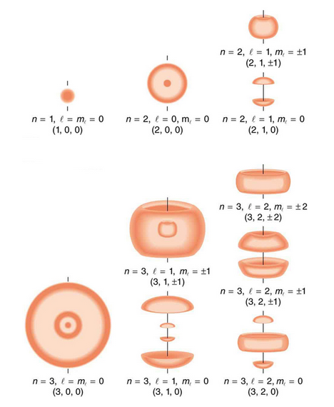

**Probability density of hydrogen electrons**: As indicated by the quantum numbers (n, l, ml), this figure depicts probability clouds for the electron in the ground state and several excited states of hydrogen.

## Quantum Numbers

Quantum numbers provide a numerical description of the orbitals in which electrons reside.

#### Important Notes

* To completely describe an electron in an atom, four quantum numbers are needed: energy (n), angular momentum (ℓ), magnetic moment (mℓ), and spin (ms).
* The first quantum number describes the electron shell, or energy level, of an atom. The value of n ranges from 1 to the shell containing the outermost electron of that atom.
* The dynamics of any quantum system are described by a quantum Hamiltonian (H).

While the work of Bohr’s and de Broglie’s clearly established that electrons take on different discrete energy levels that are related to the atomic radius, their model was a relatively simplistic spherical view. Although the energy level of an electron is related to the principal quantum number n, there were no numerical means of classifying additional aspects of the motion of an electron in space. In three dimensions, the solutions of the Schrödinger equation provided a set of three additional quantum numbers that could be used to describe the behaviour of an electron even in more complicated many-electron atoms.

To determine the number of quantum numbers needed to describe a given system, a full analysis of the system must performed. Formally, the dynamics of any quantum system are described by a quantum Hamiltonian (H) applied to the wave equation. Often there is more than one way to choose a set of independent operators; so in different situations, different sets of quantum numbers may be used for the description of the same system.

The most prominent system of nomenclature spawned from the molecular orbital theory of Friedrich Hund and Robert S. Mulliken, which incorporates Bohr energy levels as well as observations about electron spin. This model describes electrons using four quantum numbers: energy (n), angular momentum (ℓ), magnetic moment (mℓ), and spin (ms). It is also the common nomenclature in the classical description of nuclear particle states (protons and neutrons).

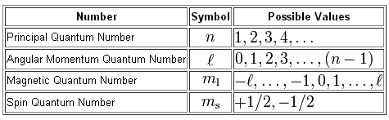

These four quantum numbers are used to describe the probable location of an electron in an atom.

### The Principal Quantum Number

The first quantum number, n describes the electron shell, or energy level of an atom and its value ranges from 1 to the shell containing the outermost electron of that atom. For example, in caesium (Cs), the outermost valence electron is in the shell with energy level 6, so an electron in caesium can have n values from 1 to 6. For particles in a time-independent potential, according to the Schrödinger equation, it also labels the nth Eigenvalue of Hamiltonian (H) (the energy E with the contribution due to angular momentum). This number therefore is dependent only on the distance between the electron and the nucleus (the radial coordinate r). Since the average distance increases with n, quantum states with different principal quantum numbers belong to different shells.

### The Azimuthal Quantum Number

The second quantum number, the angular or orbital quantum number, describes the subshell and gives the magnitude of the orbital angular momentum. In chemistry and spectroscopy, ℓ = 0 is called an s orbital, ℓ = 1 a p orbital, ℓ = 2 a d orbital, and ℓ = 3 an f orbital. The value of ℓ ranges from 0 to n − 1 because the first p orbital (ℓ = 1) appears in the second electron shell (n = 2), the first d orbital (ℓ = 2) appears in the third shell (n = 3). This quantum number is very important since it specifies the shape of an atomic orbital and strongly influences chemical bonds and bond angles.

### The Magnetic Quantum Number

The magnetic quantum number describes the energy levels available in a subshell and gives the projection of the orbital angular momentum along a specified axis. The values of mℓ range from −ℓ to +ℓ, with integer steps between them. The s subshell (ℓ = 0) contains one orbital, and therefore the mℓ of an electron in an s subshell will always be 0. The p subshell (ℓ = 1) contains three orbitals (in some systems depicted as three “dumbbell-shaped” clouds), so the mℓ of an electron in a p subshell will be −1, 0, or 1. The d subshell (ℓ = 2) contains five orbitals, with mℓ values of −2, −1, 0, 1, and 2. The value of the mℓ quantum number is associated with the orbital orientation.

### The Spin Projection Quantum Number

The fourth quantum number describes the spin (intrinsic angular momentum) of the electron in an orbital and gives the projection of the spin angular momentum (s) along the specified axis. The values of ms range from −s to s, where s is the spin quantum number. An electron has spin s = ½, consequently ms will be ±½, corresponding with spin and opposite spin. Each electron in an individual orbital must have different spins because of the Pauli Exclusion Principle (therefore an orbital never contains more than two electrons).

For example, the quantum numbers of electrons from a magnesium atom are listed below with each list of numbers corresponding to n, l, ml, ms.

Two s electrons: (1, 0, 0, +½) (1, 0, 0, -½)

Two s electrons: (2, 0, 0, +½) (2, 0, 0, -½)

Six p electrons: (2, 1, -1, +½) (2, 1, -1, -½) (2, 1, 0, +½) (2, 1, 0, -½) (2, 1, 1, +½) (2, 1, 1, -½)

Two s electrons: (3, 0, 0, +½) (3, 0, 0, -½)

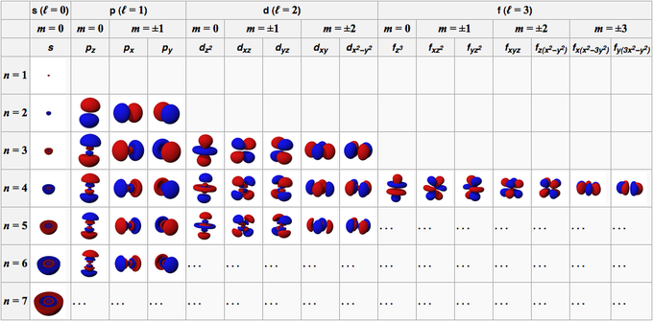

**Table relating quantum numbers to orbital shape**: The relationship between three of the four quantum numbers to the orbital shape of simple electronic configuration atoms up through radium (Ra, atomic number 88). The fourth quantum number, the spin, is a property of individual electron within a particular orbital.

## The Pauli Exclusion Principle

The Pauli Exclusion Principle states that no two fermions can have identical wave functions.

#### Note better

* No two identical electrons (particles with half- integer spin) may occupy the same quantum state simultaneously.
* No two electrons in a single atom can have the same four quantum numbers.
* Particles with integer spin occupy symmetric quantum states while particles with half-integer spin occupy asymmetric states.

The Pauli Exclusion Principle, formulated by Austrian Physicist Wolfgang Pauli in 1925, states that no two electrons may simultaneously occupy the same quantum state. Thus no two electrons in a single atom can have the same four quantum numbers; if n, ℓ, and mℓ are the same, ms must be different such that the electrons have opposite spins.

This principle governs the behaviour of all particles with half-integer spin. Atoms can have different overall spin, which determines what they are. For example, helium-3 has spin ½ while helium-4 which has spin 0. The Pauli Exclusion Principle determines many properties of everyday matter from large-scale stability to the chemical behaviour of atoms including their visibility in NMR spectroscopy.

Half-integer spin means the intrinsic angular momentum value of the material is ℏ = h/2π (reduced Planck’s constant) times a half-integer (1/2, 3/2, 5/2, etc.). In the theory of quantum mechanics, particles like electrons are described by asymmetric states. In contrast, particles with integer spin have symmetric wave functions thus not sharing the same quantum states.

### The Exclusion Principle and Physical Phenomena

The Pauli Exclusion Principle explains a wide variety of physical phenomena. One particularly important consequence of the principle is the elaborate electron-shell structure of atoms and the way atoms share electrons. It explains the variety of chemical elements and their chemical combinations. An electrically neutral atom contains bound electrons equal in number to the protons in the nucleus. Electrons, being fermions, cannot occupy the same quantum state, so electrons have to “stack” within an atom—they have different spins while at the same place.

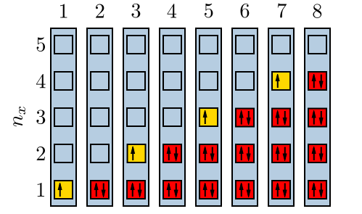

**Electrons filling quantum energy levels**: When a state has only one electron, it could be either spin-up or spin-down. However, according the Pauli Exclusion Principle, when there are two in a state, they must be paired.

An example is the neutral helium atom, which has two bound electrons, both of which can occupy the lowest- energy (1s) states by acquiring opposite spins. As spin is part of the quantum state of the electron, the two electrons are in different quantum states and do not violate the Pauli Exclusion Principle. However, there are only two distinct spin values for a given energy state. This property thus mandates that a lithium atom, which has three bound electrons, cannot have its third electron reside in the 1s state; it must occupy one of the higher-energy 2s states instead. Similarly, successively larger elements must have shells of successively higher energy. Since the chemical properties of an element largely depend on the number of electrons in the outermost shell, atoms with different numbers of shells but the same number of electrons in the outermost shell still behave similarly. For this reason, elements are defined by their groups and not their periods.

## Wave Equation for the Hydrogen Atom

The hydrogen atom is the simplest one-electron atom and has analytical solutions to the Schrödinger equation.

#### Note the following points

* The Schrödinger equation calculates the possible wave functions of a system and describes how they dynamically change in time.
* Particles behave like waves because their corresponding wave function satisfies the Schrödinger equation.
* The motion of a particle, described by the solution to the Schrödinger equation, is also described by the Hamilton–Jacobi equation of motion.

The solution of Schrödinger equation for the hydrogen atom uses the fact that the Coulomb potential produced by the nucleus is radially symmetrical in space and only dependent on the distance from the nucleus. Also, the angular momentum of an electron is conserved in the orbital motion of the electron around the nucleus. The energy Eigen states of the electron is classified by two angular momentum quantum numbers, ℓ and mℓ. The angular momentum quantum number ℓ = 0, 1, 2,… determines the magnitude of the angular momentum. The magnetic quantum number mℓ= − ℓ, ., +ℓ, determines the orientation of the orbital in three-dimensional space.

The radial dependence of the wave functions which gives the details of the 1/r Coulomb potential is explainable by a third quantum number, the principal quantum number n = 1, 2, 3,…. The principal quantum number in hydrogen is related to the total energy of its atom with the maximum value of the angular momentum quantum number being limited by the principal quantum number (can run only up to n − 1, i.e. ℓ = 0, 1… n – 1).

### Degeneracy of Different Magnetic Quantum Numbers

Since angular momentum is conserved, states of the same ℓ but different mℓ have the same energy. This holds for all problems with rotational symmetry. For the hydrogen atom, states of the same n but different ℓ are also degenerate (have the same energy) but only specific to hydrogen and is not true for more complicated atoms. These atoms have effective potentials differing from the 1/r form due to the presence of the inner electrons shielding the nuclear potential.

Bottom of Form

## The Covalent Bond

## Comparing covalent and ionic compounds, they have distinct physical properties.

#### Very Important Notes

* Ionic compounds are formed from strong electrostatic interactions between ions resulting in in higher melting points and electrical conductivity compared to covalent compounds.
* Covalent compounds have bonds in which electrons are shared between atoms thus exhibit characteristic physical properties as lower melting points and electrical conductivity than ionic compounds.

### Two Classes of Compounds

Compounds are substances containing two or more different chemical elements. They have distinct chemical structures characterized by a fixed ratio of atoms held together by chemical bonds. Based on bond type, there two major types of compounds namely, ionic and covalent.

### Covalent Compounds

Covalent bonds are characterized by the sharing of electrons between two or more atoms. These bonds mostly occur between nonmetals or between two of the same (or similar) elements. Two atoms with similar electronegativity will not exchange an electron from their outermost shell; instead, they share electrons so that their valence electron shell is filled.

Examples of compounds that contain only covalent bonds are methane (CH4), carbon(II) oxide (CO), and iodine bromide (IBr).

**Covalent bonding between hydrogen atoms**: Since each hydrogen atom has one electron, it is able to fill its outermost shell by sharing a pair of electrons with another through a covalent bond.

### Ionic Compounds

Ionic bonding occurs when there is a large difference in electronegativity between two atoms. This large difference leads to the loss of an electron from the less electronegative atom and the gain of that electron by the more electronegative atom, resulting in two ions. These oppositely charged ions feel an attraction to each other and this electrostatic attraction constitutes an ionic bond.

Ionic bonding occurs between a nonmetal, an electron acceptor and a metal, an electron donor. Metals have few valence electrons, whereas nonmetals have closer to eight valence electrons; to easily satisfy the octet rule, the nonmetal accepts an electron donated by the metal. More than one electrons can be donated and received in an ionic bond.

Some examples of compounds with ionic bonding include NaCl, KI, MgCl2. This can be illustrated by the **formation of sodium fluoride (NaF) in which th**e transfer of an electron from a neutral sodium atom to a neutral fluorine atom creates two oppositely charge ions: Na+ and F–. Attraction of the oppositely charged ions is the ionic bond between Na and F as shown below.



### Effect on Physical Properties

Covalent and ionic compounds can be differentiated easily because of their different physical properties based on the nature of their bonding. Here are some differences:

1. At room temperature and normal atmospheric pressure, covalent compounds may exist as solids, liquids, or gases, whereas ionic compounds exist only as solids.
2. Although solid ionic compounds do not conduct electricity (no free mobile ions or electrons), ionic compounds dissolved in water form electrolytes. Covalent compounds do not exhibit electrical conductivity, either in pure form or when dissolved in water.
3. Ionic compounds exist in stable crystalline structures. Therefore, they have higher melting and boiling points compared to covalent compounds.

## Single Covalent Bonds

Single covalent bonds are sigma bonds, which occur when one pair of electrons is shared between atoms.

#### Note that:

* Covalent bonds occur when electrons are shared between two atoms and a single covalent bond results when only one pair of electrons is shared between atoms.
* A sigma bond is the strongest type of covalent bond, in which the atomic orbitals directly overlap between the nuclei of two atoms.
* Sigma bonds can occur between any kinds of atomic orbitals; the only requirement is that the atomic orbital overlap is directly between the nuclei of atoms.

### Hierarchical Structure of the Atom

There are four hierarchical levels that describe the position and energy of the electrons in an atom. Here they are listed along with some of the possible values (or letters) they can have:

* 1. Principal energy levels, n (1, 2, 3, etc.) (2) Sublevels (s, p, d, f)
  2. Orbitals (4) Electrons

Principal energy levels are made out of sublevels which are, in turn, made out of orbitals in which electrons are found.

### Atomic Orbitals

An atomic orbital is defined as the probability of finding an electron in an area around the nucleus of an atom. Orbital shapes are drawn to describe the region in space where electrons are likely to be found. This is referred to as “electron density.”

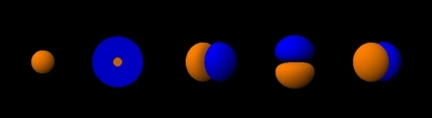

**Atomic orbitals**: The shapes of the first five atomic orbitals are shown in order: 1s, 2s and the three 2p orbitals. Both blue and orange-shaded regions represent regions in space where electrons can be found ‘belonging’ to these orbitals.

### Sigma Bonds

Covalent bonding occurs when two atomic orbitals come together in close proximity and their electron densities overlap. The strongest type of covalent bonds are sigma bonds which are formed by the direct overlap of orbitals from each of the two bonded atoms. Regardless of the atomic orbital type, sigma bonds can occur as long as there are direct overlap of the atomic nuclei.

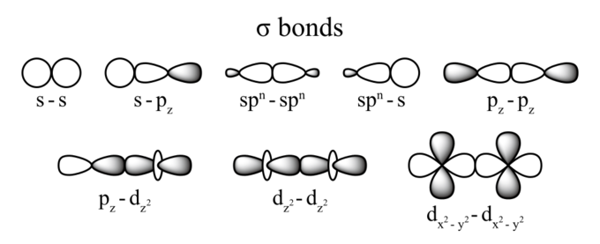

**Orbital overlaps and sigma bonds**: These are all possible overlaps between different types of atomic orbitals that result in the formation of a sigma bond. The area of overlap always occurs between the nuclei of the two bonded atoms.

Single covalent bonds occur when one pair of electrons is shared between atoms as part of a molecule or compound. A single covalent bond can be represented by a single line between the two atoms. For instance, the diatomic hydrogen molecule, H2, can be written as H—H to indicate the single covalent bond between the two hydrogen atoms.

## Double and Triple Covalent Bonds

Double and triple bonds are made up of sigma and pi bonds and these increase the stability and restrict the geometry of a compound. Double and triple covalent bonds occur when four or six electrons are shared between two atoms and are indicated in Lewis structures by drawing two or three lines connecting one atom to another. Only atoms with the need to gain or lose at least two valence electrons through sharing can participate in multiple bonds.

#### Note that:

* Double and triple covalent bonds are stronger than single covalent bonds and are characterized by the sharing of four or six electrons between atoms, respectively.
* Double and triple bonds are made up of sigma bonds between hybridized orbitals and pi bonds between unhybridized p orbitals. Double and triple bonds offer added stability to compounds and restrict any rotation around the bond axis.
* Bond lengths between atoms with multiple bonds are shorter than in those with single bonds.

### Bonding Concepts

### Hybridization

Double and triple bonds can be explained by orbital hybridization (‘mixing’ of atomic orbitals to form new hybrid orbitals). Hybridization describes the bonding situation from a specific atom’s point of view. A combination of s and p orbitals results in the formation of hybrid orbitals. These hybrid orbitals all have the same energy and specific geometrical arrangement in space that agree with the observed bonding geometry in molecules. Hybrid orbitals are denoted as spx, where s and p are the orbitals used for mixing and the value of the superscript x ranges from 1-3 depending on the number of p orbitals required to explain the observed bonding. The sum of the superscripts (1 for s, and 3 for p) gives the total number of the formed hybrid orbitals. In this case, four orbitals are produced which point along the direction of the vertices of a tetrahedron.

### Pi Bonds

Pi, or π, bonds occur when there is overlap between unhybridized p orbitals of two adjacent atoms. The overlap does not occur between the nuclei of the atoms and this is the key difference between sigma and pi bonds. For the bond to form efficiently, there has to be a proper geometrical relationship between the unhybridized p orbitals (they must be on the same plane).



**Pi bond formation**: Overlap between adjacent unhybridized p orbitals produces a pi bond. The electron density corresponding to the shared electrons is not concentrated along the internuclear axis (i.e., between the two atoms), unlike in sigma bonds.

Multiple bonds between atoms always consist of a sigma bond, with any additional bonds being of the π type.

### Examples of Pi Bonds

The simplest example of an organic compound with a double bond is ethylene, or ethene, C2H4. The double bond between the two carbon atoms consists of a sigma bond and a π bond.

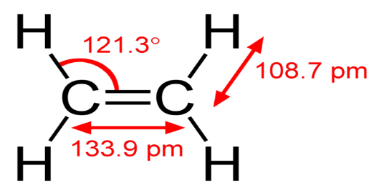

**Ethylene bonding**: An example of a simple molecule with a double bond between carbon atoms. The bond lengths and angles (indicative of the molecular geometry) are indicated.

From the perspective of the carbon atoms, each has three sp2 hybrid orbitals and one unhybridized p orbital. The three sp2 orbitals lie in a single plane at 120-degree angles. As the carbon atoms approach each other, their orbitals overlap and form a bond. Simultaneously, the p orbitals approach each other and form a bond. To maintain this bond, the p orbitals must be parallel to each other; therefore, rotation is not possible.

A triple bond involves the sharing of six electrons, with a sigma bond and two ππ bonds. The simplest triple-bonded organic compound is ethyne, C2H2. Triple bonds are stronger than double bonds due to the presence of two π bonds rather than one. Each carbon has two sp hybrid orbitals, and one of them overlaps with its corresponding one from the other carbon atom to form an sp-sp sigma bond. The remaining four unhybridized p orbitals overlap with each other and form two ππ bonds. Similar to double bonds, no rotation around the triple bond axis is possible.

### Observable Consequences of Multiple Bonds

### Bond Strength

Covalent bonds can be classified in terms of the amount of energy required to break them. Based on the experimental observation that more energy is needed to break a bond between two oxygen atoms in O2 than two hydrogen atoms in H2, it means that the oxygen atoms are more tightly bound together thus, the bond between the two oxygen atoms is stronger than that between two hydrogen atoms.

Experiments have shown that double bonds are stronger than single ones and triple bonds are stronger than double. Thus, it takes more energy to break the triple bond in N2 compared to the double bond in O2 with 497 kJ/mol needed to break the O2 molecule and 945 kJ/mol to break N2.

### Bond Length

Another consequence of the presence of multiple bonds between atoms is the difference in the distance between the nuclei of the bonded atoms. Double bonds have shorter distances than single bonds, and triple bonds are shorter than double bonds.

## Physical Properties of Covalent Molecules

The covalent bonding model helps predict many of the physical properties of compounds.

#### Take Note of the following Points

* The Lewis theory of covalent bonding says that the bond strength of double bonds is twice that of single bonds, which is not true.
* General physical properties that can be explained by the covalent bonding model include boiling and melting points, electrical conductivity, bond strength, and bond length.
* The strength of **intermolecular forces** is an important factor that determines the physical properties of substances.
* Atoms lose, gain, or share electrons in order to have full valence shells of eight electrons although hydrogen is an exception because it can hold a maximum of two electrons in its valence level.

First described by Gilbert Lewis, a covalent bond occurs when electrons of different atoms are shared between the two atoms. These cases of electron sharing can be predicted by the octet rule. The octet rule generalizes that atoms of low atomic number (< 20) will combine in a way that results in their having 8 electrons in their valence shells. Having 8 valence electrons is favourable for stability and is similar to the electron configuration of the noble gases. In a covalent bond, the shared electrons contribute to each atom’s octet and thus enhance the stability of the compound.

The Lewis bonding theory can explain many properties of compounds. For example, the theory predicts the existence of diatomic molecules such as hydrogen, H2 and the halogens (F2, Cl2, Br2, I2). A H atom needs one additional electron to fill its valence level and the halogens need one more electron to fill the octet in their valence levels. Lewis’ bonding theory states that these atoms will share their valence electrons, effectively allowing each atom to create its own octet.

Several physical properties of molecules/compounds are related to the presence of covalent bonds:

* Covalent bonds between atoms are quite strong while attractions between molecules/compounds or intermolecular forces can be relatively weak. Covalent compounds generally have low boiling and melting points and are found in all three physical states at room temperature.
* Covalent compounds do not conduct electricity because covalent compounds do not have charged particles capable of transporting electrons.
* Lewis’ theory also accounts for bond length; the stronger the bond and the more electrons shared, the shorter the bond length is.

However, the Lewis theory of covalent bonding does not account for some observations of compounds in nature. The theory predicts that with more shared electrons, the bond between the two atoms should be stronger. According to the theory, triple bonds are stronger than double bonds, and double bonds are stronger than single bonds. Although this is true, the theory implies that the bond strength of double bonds is twice that of single bonds, which is not true. Therefore, while the covalent bonding model accounts for many physical observations, it does have its limitations.

Bottom of Form

## The Ionic Bond

## Ionic Bonding and Electron Transfer

An ionic bond results from the transfer of at least an electron from a metal atom to a non-metal atom.

#### Note that:

* Ionic bonds are formed between cations and anions.
* A cation is formed when a metal ion loses its valence electron(s) while an anion is formed when a non-metal gains valence electron(s). They both form more stable electronic configurations through this exchange.
* Ionic solids form crystalline lattices, or repeating patterns of atoms, with high melting points and are soluble in water.

### Ionic Bonds

Ionic bonding is a type of chemical bond in which valence electrons are lost from one atom and gained by another. This exchange results in a more stable, noble gas electronic configuration for both atoms involved and it is based on attractive electrostatic forces between two ions of opposite charges.

### Cations and Anions

Ionic bonds involve a cation and an anion. The bond is formed when an atom, typically a metal, loses an electron or electrons and becomes a positive ion or cation. Another atom, typically a non-metal, is able to acquire the electron(s) to become a negative ion, or anion. An example of ionic bond is the formation of sodium fluoride, NaF, from a sodium atom and a fluorine atom. In this reaction, the sodium atom loses its single valence electron to the fluorine atom, which has just enough space to accept it. The ions produced are oppositely charged and are attracted to one another due to electrostatic forces.



Ionic compounds form lattices, are crystalline solids under normal conditions and have high melting points. Most of them are soluble in H2O and conduct electricity when dissolved. The ability to conduct electricity in solution is why these substances are called electrolytes. Table salt, NaCl, is a good example of this type of compounds.

Ionic bonds differ from covalent bonds although both result in the stable electronic states associated with the noble gases. However, in covalent bonds, the electrons are shared between the two atoms. All ionic bonds have some covalent character, but the larger the difference in electronegativity between the two atoms, the greater the ionic character of the interaction.

## Lattice Energy

Lattice energy is a measure of the bond strength in an ionic compound.

#### Points to Note

* Lattice energy is the energy required to separate a mole of an ionic solid into gaseous ions.
* Lattice energy cannot be measured empirically, but can be calculated using electrostatics or the Born-Haber cycle.
* Two main factors that contribute to the magnitude of the lattice energy are the charge and radius of the bonded ions.

### Definition of Lattice Energy

Lattice energy is an estimate of the bond strength in ionic compounds. It is defined as the heat of formation for ions of opposite charges in the gas phase to form ionic solids. As an example, the lattice energy of sodium chloride, NaCl, is the energy released when gaseous Na+ and Cl– ions come together to form a lattice of alternating ions in the NaCl crystal.

Na+(g) + Cl−(g) → NaCl(s) ΔH = −787.3 kJ/mol

The negative sign of the energy is indicative of an exothermic reaction.

Alternatively, lattice energy can be define as the energy required to separate a mole of an ionic solid into the gaseous forms of its ions (that is, the reverse of the reaction shown above).

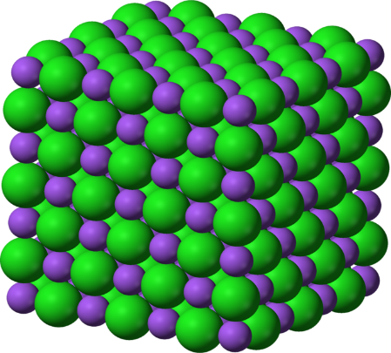

**NaCl Crystalline Lattice**: Sodium ions (Na+) and chloride (Cl–) ions, depicted in purple and green respectively, alternate in the crystal lattice of solid NaCl.

Alternatively, lattice energy can be thought of as the energy required to separate a mole of an ionic solid into the gaseous form of its ions (that is, the reverse of the reaction shown above).

Lattice energy cannot be determined experimentally due to the difficulty in isolating gaseous ions. The energy value can be estimated using the Born-Haber cycle, or it can be calculated theoretically with an electrostatic examination of the crystal structure.

### Factors Affecting Lattice Energy

In 1918, Born and Lande presented the following model for lattice energy:

In this equation, NA is Avogadro’s constant; M is the Madelung constant, which depends on the crystal geometry; z+ is the charge number of the cation; z– is the charge number of the anion; e is the elementary charge of the electron; n is the Born exponent, a characteristic of the compressibility of the solid, ϵo is the permittivity of free space and r0 is the distance to the closest ion.

This model emphasizes two main factors that contribute to the lattice energy of an ionic solid: the charge on the ions and the radius or size of the ions. The effect of those factors is:

* as the charge of the ions increases, the lattice energy increases
* as the size of the ions increases, the lattice energy decreases

Lattice energies are also important in predicting the solubility of ionic solids in H2O. Ionic compounds with smaller lattice energies tend to be more soluble in H2O.

## Formulae of Ionic Compounds

Ionic formulae must satisfy the noble gas configurations for the constituent ions and the product compound must be electrically neutral.

### Ionic Compounds

An ionic bond is formed through the transfer of one or more valence electrons, typically from a metal to a non-metal, which produces a cation and an anion that are bound together by an attractive electrostatic force. Ionic compounds, such as sodium chloride (NaCl), form crystalline lattices and are solids at normal temperatures and pressures.

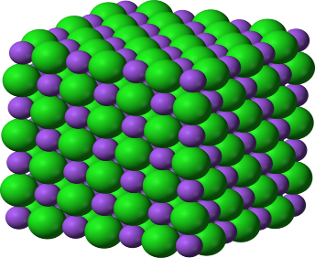

**The crystalline lattice of** Sodium chloride

The charge on the cations and anions is determined by the number of electrons required to achieve stable noble gas electronic configurations. The ionic composition is then defined by the requirement that the resulting compound be electrically neutral overall. For example, to combine magnesium (Mg) and bromine (Br) to get an ionic compound, we first note the electronic configurations of these atoms (valence level in indicated in italics):

Mg: 1s22s22p63s2

Br: 1s22s22p63s23p63d104s24p5

In order to achieve noble gas configurations, the magnesium atom needs to lose its two valence electrons while the bromine atom, which has 7 valence electrons, requires one additional electron to fill its outer shell. Therefore, for the resulting compound to be neutral, two bromine anions must combine with one magnesium cation to form magnesium bromide (MgBr2). In addition, though any ratio of 2 bromine atoms to 1 magnesium atom will satisfy the two requirements above, the formula for ionic compounds is typically presented as the empirical formula, or the simplest whole-number ratio of atoms with positive integers. In these presentations, the cations always precede the anions both in written forms and in formulae. In the written form, while the cation name is generally the same as the element, the suffix of single-atom anions is changed to –ide, as in the case of sodium chloride. If the anion is a polyatomic ion, its suffix can vary, but is typically either –ate or –ite, as in the cases of sodium phosphate and calcium nitrite, depending on the identity of the ion.

More examples:

* lithium fluoride: Li+ and F– combine to form LiF
* calcium chloride: Ca2+ and Cl– combine to form CaCl2
* iron(II) oxide: Fe2+ and O2- combine to form FeO
* aluminum sulphide: Al3+ and S2- combine to form Al2S3
* sodium sulphate: Na+ and SO42- combine to form Na2SO4
* ammonium phosphate: NH4+ and PO43- combine to form (NH4)3PO4
* potassium chlorite: K+ and ClO2– combine to form KClO2

## Ionic vs Covalent Bond Character

Ionic bonds can have some covalent character and the following points are to be noted.

* Ionic bonding is presented as the complete transfer of valence electrons, typically from a metal to a non-metal.
* Electron density remains shared between the constituent atoms, meaning all bonds have some covalent character.
* The ionic or covalent nature of a bond is determined by the relative electronegativities of the atoms involved.

### Ionic vs Covalent Bonding

Chemical compounds are classified by the bonds between constituent atoms. There are multiple kinds of attractive forces including covalent, ionic and metallic bonds. Ionic bonding models are presented as the complete loss or gain of one or more valence electrons from a metal to a nonmetal resulting in cations and anions that are held together by attractive electrostatic forces.

**Example of a polar covalent bond:** When a carbon atom forms a bond with fluorine, they share a pair of electrons. However, because fluorine is more highly electronegative than carbon, it attracts that shared electron pair closer to itself and thus creates an electric dipole. The uppercase Greek delta written above the atoms is used to indicate the presence of partial charges. This bond is considered to have characteristics of both covalent and ionic bonds.

i.e. Cδ+  Fδ-

In reality, the bond between these atoms is more complex than this model illustrates. The bond formed between any two atoms is not a purely ionic bond. Therefore, all bonding interactions have some covalent character because the electron density remains shared between the atoms. The degree of ionic to covalent character of a bond is determined by the difference in electronegativity between the constituent atoms. The larger the difference, the more ionic the nature of the bond. However, bonds are designated as ionic when the ionic aspect is greater than the covalent aspect. Bonds that fall in between the two extremes, having both ionic and covalent character, are classified as polar covalent bonds. Such bonds are thought of as consisting of partially charged positive and negative poles.

Though ionic and covalent character represent points along a continuum, these designations are frequently useful in understanding and comparing the macroscopic properties of ionic and covalent compounds. For example, ionic compounds typically have higher boiling and melting points and are also usually more soluble in water than covalent compounds.

**Explanation of the Shapes of Molecules**

Bottom of Form

## Applying the VSEPR (Valence Shell Electron Pair Repulsion) Model

In the VSEPR model, the number of electron pairs around a central atom dictates a molecule’s general shape.

#### Points to Note in this Model

* Electron repulsion between orbitals dictates molecular geometry.
* Nonbonding electron orbitals differ from bonding orbitals because nonbonding orbitals are concentrated closer to the central atom.
* Nonbonding orbitals exert more repulsion on other orbitals; for example, although the oxygen is tetrahedral in H2O, the shape of the molecule is bent, forming v-shape.

### VSEPR as a Tool for Explaining the Shapes of Molecules

The valence shell electron pair repulsion (VSEPR) model predicts the shape of molecules based on the extent of electron-pair electrostatic repulsion. According to VSEPR, the valence electron pairs surrounding an atom mutually repel each other (they adopt an arrangement that minimizes this repulsion) thus determining the molecular geometry. This means that the bonding (and non-bonding) electrons will repel each other as far away as geometrically possible. The number of atoms bonded to a central atom combined with the number of pairs of its nonbonding valence electrons is called its steric number.

### Nonbonding Electrons and the Coordination Number

When calculating the coordination number around the central atom, count both the bonded atoms and the nonbonding pairs, because the nonbonding electrons are also in orbitals that occupy space and repel the other orbitals. For example, a water molecule (H2O) is not a linear molecule, because the Lewis electron dot formula predicts that there are two pairs of nonbonding electrons.

The oxygen atom is therefore tetrahedrally coordinated, meaning that it sits at the center of a tetrahedron. Two of the coordination positions are occupied by the shared electron-pairs that constitute the O–H bonds and the other two by the non-bonding pairs. Therefore, although the oxygen atom is tetrahedrally coordinated, the bonding geometry (shape) of the H2O molecule is bent (V-shaped).

Bonding and non-bonding electron orbitals greatly differ. A nonbonding orbital has no atomic nucleus at its far end to draw the electron cloud towards it thus, the charge will be concentrated closer to the central atom with the nonbonding orbitals exerting more repulsion on other orbitals than the bonding orbitals.

In H2O for example, the two nonbonding orbitals push the bonding orbitals closer together, making the H–O–H angle 104.5° instead of the tetrahedral angle of 109.5°. Although the water molecule is electrically neutral, it is not electrically uniform; the non-bonding electrons create a higher concentration of negative charge at the oxygen end, making the hydrogen side relatively positive. This unbalanced charge is the root of water’s many anomalous properties.

### Linear Molecules

A triatomic molecule of the type AX2 has its two bonding orbitals 180° apart, producing a molecule of linear geometry; examples of this include BeCl2 and CO2. In the electron dot formula for carbon dioxide, the C-O bonds are double thus. makes no difference from VSEPR theory; the central carbon atom is still joined to two other atoms and the electron clouds that connect the two oxygen atoms are 180° apart.

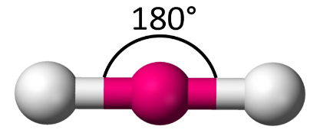

### Trigonal Molecules

In an AX3 molecule, such as BF3, three regions of electron density extend out from the central atom. The repulsion between these will be at a minimum when the angle between any two is 120°. This requires that all four atoms are in the same plane; the resulting shape is called trigonal planar, or simply trigonal.

### Tetrahedrally-Coordinated Carbon Chains

In an AX4 molecule such as methane (CH4), the central atom is bonded to four other atoms. The four equivalent bonds point in four geometrically equivalent directions in three dimensions corresponding to the four corners of a tetrahedron; this is called tetrahedral coordination. The angle between any two bonds is 109.5° and the bonding geometry is tetrahedral when the valence shell of the central atom contains nonbonding electrons.

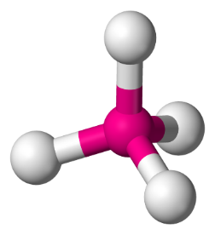

**Tetrahedral molecule**: In a tetrahedral molecule, four equivalent bonds point in four geometrically equivalent directions in three dimensions, corresponding to the four corners of a tetrahedron centered on the carbon atom. Each bond angle is 109.5 °C.

### Central Atoms with Five Bonds

Compounds of the type AX5 are formed by some of the elements in Group 15 of the periodic table. Examples of these compounds include PCl5 and AsF5.

Molecules with coordination number of 5 are in the shape of a trigonal bipyramid; this consists of two triangular-based pyramids joined base-to-base. For example, in a PCl5 molecule, three of the chlorine atoms are in the central phosphorus atom’s plane (equatorial positions), while the other two atoms are above and below this plane (axial positions).

Equatorial and axial atoms have different geometrical relationships to their neighbors, and thus differ slightly in their chemical behavior. In 5-coordinated molecules containing lone pairs, these non-bonding orbitals will preferentially reside in the equatorial plane at 90° angles, with respect to no more than two axially-oriented bonding orbitals. An AX4E molecule (one in which the central atom is coordinated to four other atoms and to one nonbonding electron pair) has a “see-saw” shape; substituting more nonbonding pairs for bonded atoms reduces the triangular bipyramid coordination to even simpler molecular shapes.

### Octahedral Coordination

In an AX6 molecule, six electron pairs will try to point toward the corners of an octahedron (two square-based pyramids joined base-to-base). The shaded plane shown in the figure is only one of three equivalent planes defined by a four-fold symmetry axis. All the ligands are geometrically equivalent with bond angles of 90°; there are no separate axial and equatorial positions.

A coordination number of 6 is one of the most commonly encountered in inorganic chemistry, specifically in transition metal hydrates such as Fe(H2O)63+. There are well known examples of 6-coordinate central atoms with one, two, and three lone pairs.

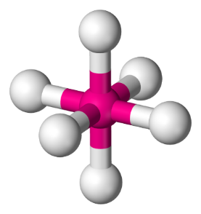

**Octahedral molecule**: In an octahedral molecule, six electron pairs point towards the corners of an octahedron.